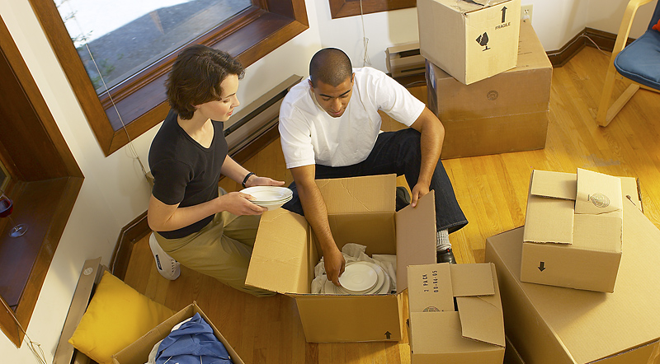
New to the Area?
Stop by a Toastmasters meeting
and make some new friends!
Toastmasters are warm, friendly people who get together on a regular
basis to improve our communication skills. We provide a supportive and positive learning environment, great feedback, and lots of suggestions for how to improve.
... and we have LOTS of FUN doing it!

Visitors are Always Welcome!

(Club) Toastmasters
(Meeting days / time)

(Venue / Address)

Call (0416 xxx xxx or visit www.clubname.com for more information!)

